FYP2 Final Report

Virtual Classroom

Ahsaan Ullah 17I-0133

Fasih saeed 17I-0245

M. Uzair Ibrar 17I-0300

Supervised By : Mr. Jawad Hassan

June 25, 2021

**Anti-Plagiarism Declaration**

This is to declare that the above FYP report produced under the:

**Title: Virtual Classroom**

is the sole contribution of the author(s) and no part here of has been reproduced on as it is basis (cut and paste) which can be considered as Plagiarism. All referenced parts have been used to argue the idea and have been cited properly. I/We will be responsible and liable for any consequence if violation of this declaration is determined.

June 25, 2021

Student 1

Name: Ahsaan Ullah

Signature: \_\_\_\_\_\_\_\_\_\_\_\_\_\_\_\_\_\_\_

Student 2

Name: Fasih Saeed

Signature: \_\_\_\_\_\_\_\_\_\_\_\_\_\_\_\_\_\_\_

Student 3

Name: Uzair Ibrar

Signature: \_\_\_\_\_\_\_\_\_\_\_\_\_\_\_\_\_\_\_

Supervisor (Faculty)

Name: Mr. Jawad Hassan

Signature: \_\_\_\_\_\_\_\_\_\_\_\_\_\_\_\_\_\_\_

Content

[Introduction 1](#_Toc75554920)

[Project Vision 1](#_Toc75554922)

[2.1 Problem Statement 1](#_Toc75554923)

[2.2 Objectives 2](#_Toc75554924)

[2.3 Project Scope 2](#_Toc75554925)

[3. Software requirement Specifications 3](#_Toc75554927)

[3.1 List of features 3](#_Toc75554928)

[3.2 Functional requirements 3](#_Toc75554934)

[3.3. Quality attributes 3](#_Toc75554935)

[3.4 Nonfunctional requirements 4](#_Toc75554936)

[High level Use cases 4](#_Toc75554937)

[4.1. Use Cases List 4](#_Toc75554938)

[4.2. Use Cases 5](#_Toc75554939)

[4.3 Use Case Diagram 8](#_Toc75554940)

[5. Iteration Plan 9](#_Toc75554941)

[6. Iteration 1 10](#_Toc75554942)

[6.1 Expanded use case 10](#_Toc75554943)

[6.2 Activity Diagram 14](#_Toc75554944)

[6.3 Domain Model 15](#_Toc75554945)

[6.4. System Sequence Diagram 16](#_Toc75554946)

[6.4.a. UC-102 16](#_Toc75554947)

[6.4.b. UC-103 17](#_Toc75554948)

[6.4.b. UC-104 17](#_Toc75554949)

[6.4.b. UC-105 18](#_Toc75554950)

[6.4.b. UC-106 18](#_Toc75554951)

[6.5. Operation Contracts 19](#_Toc75554952)

[6.5.a. Contract use case ID: UC-101 19](#_Toc75554953)

[6.5.b. Contract use case ID: UC-102 19](#_Toc75554957)

[6.5.c. Contract use case ID: UC-103 19](#_Toc75554959)

[6.5.d. Contract use case ID: UC-104 20](#_Toc75554960)

[6.5.e. Contract use case ID: UC-105 20](#_Toc75554962)

[6.5.f. Contract use case ID: UC-106 20](#_Toc75554964)

[6.5.g. Contract use case ID: UC-107 21](#_Toc75554966)

[6.6. Sequence diagrams 22](#_Toc75554968)

[6.6.a. UC-102 22](#_Toc75554969)

[6.6.a. UC-103 23](#_Toc75554970)

[6.6.1 a. UC-103 24](#_Toc75554971)

[6.7. Class Diagram 25](#_Toc75554972)

[6.8 Entity Relationship Diagram 26](#_Toc75554973)

[6.9. Architecture diagram 26](#_Toc75554974)

[7 Deployment diagram 27](#_Toc75554975)

[8 Implementation Details 28](#_Toc75554976)

[Front-End Implementation : 28](#_Toc75554977)

[Back-End Implementation : 28](#_Toc75554978)

[API’s and Libraries: 28](#_Toc75554979)

[Open CV - Eye Tracking : 29](#_Toc75554980)

[8 User Manual 30](#_Toc75554981)

[Registration Of Student 30](#_Toc75554982)

[Log In to the System 30](#_Toc75554983)

[Access to the System 31](#_Toc75554984)

[Video Conferencing 31](#_Toc75554985)

[Whiteboard 32](#_Toc75554986)

[Time Schedule 32](#_Toc75554987)

[Screesharing 33](#_Toc75554988)

[Problems Faced: 33](#_Toc75554989)

[Conclusion 34](#_Toc75554990)

# **Introduction**

## The purpose of this document is to build an online virtual classroom through which students can take online classes and can access the content using cloud services.

Attendance, Engagement estimation and measuring Percentage of presence and Data Analytics has always been a major problem in all sorts of available classrooms till now. As we all know that world is moving toward digital education, for that purpose Virtual classrooms are very important for conducting off-campus classes. There are many virtual classrooms with basic features, but the problem of real time Student's attendance, Engagement, Percentage of presence in a lecture and Data analytics has not been solved yet ; in other words these features are not available in any of the available virtual classroom.  
These problems are interesting and important to consider as the community is majorly  
facing such issues. These problems has been noticed these days when the world has started setting their classes online, to keep stats of students performance, engagement and attendance in off-campus classes, We should have a proper environment managing these stuffs automatically.  
we hope to develop a perfect platform to enhance online education and academia to keep  
track of individual students through analysis

# **Project Vision**

Our vision is to provide people with hearing disabilities a better life where they can communicate easily with the whole world. We hope that this application will be a great step for them to be able to live a normal life without problems they may be facing due to their disabilities.

## **2.1 Problem Statement**

Online learning has been rapidly adopted due to wide-spread access, and the many benefits it  
offers. Students no longer need to commute to a classroom and are often able to learn at their  
own pace. All they need is an internet connection to communicate with tutors.

A key problem in this process is analyzing student’s performance and  
engaging them in classroom activities like online lectures. The modern world lacks the solution  
which provides an appropriate analysis of students and the solution through which  
institutional mentors can check engagement in an online classroom. This gap is making online  
education less attractive than a traditional classroom.

We as a team try to provide a web platform through which mentors as well as  
students can take full advantage of online learning. This tool will mostly be focused on  
providing mentors fashioning teaching experiences. It’ll analytical tool through which mentors  
can take an in-depth report about every student’s performance and also go through the  
student engagement in classroom activities

## **2.2 Objectives**

* + Create a web-based platform through which students can take online  
    classes and can access the content using cloud services.
  + Institutional mentors can check the presence of a student in an online  
    class using eye-tracking.
  + Institutional mentors can analyze the engagement of the student in a  
    certain course through his/her performance in the course.

Provide a Dashboard to mentors to visualize the result of analyses

## **2.3 Project Scope**

## This project will be an interactive web platform for students and institutional mentors to take online education. After the release of this project, students will be able to interact with their mentors with full ease but it’ll mostly be focused on providing the mentors a platform or tool through which they can take an in-depth report about every student’s performance and also go through the student engagement in classroom activities. It will also have the feature automatic attendance by the system . After that we will implement different computer science techniques such as Artificial Intelligence, Machine Learning and Data warehouse to implement the core features of our project. Then combined with the basic features of our classroom, these core features will play an important role for solving the problems currently faced by virtual classroom platforms.

e application further.

# **3. Software requirement Specifications**

## **3.1 List of features**

## Students Percentage Of presence in a lecture (In Class of an hour how much time the student was focused in lecture).

## Automatic attendance by the system using facial recognition.

## Detecting unnecessary voice / kicking those students who are making noise.

## Student Engagement in lectures through assignments seek. (Content Based).

## Generate automated reports for keeping record. Attendance and performance reports.

## **3.2 Functional requirements**

The main functional requirements of our project is:

1. The system must register students and teachers.
2. The system must offer courses to the students.
3. The students must be able to register courses.
4. There must be live lectures of the offered courses.
5. The live lecture must provide audio, video, chat box and white board to students and teacher.
6. The system must calculate the percentage of presence of the student during a live lecture through eye tracking.
7. The student’s attendance will be calculated upon calculating the percentage of presence of the students.
8. The system must maintain record of student’s attendance, the assignments submitted and the quizzes he attempted.
9. The system must store the lectures in the form of live lectures and files on the cloud so that it is later accessible to the students.

## **3.3. Quality attributes**

|  |  |
| --- | --- |
| **Attribute** | **Brief Detail** |
| **Use-ability** | The application provides easy to use interface, that anyone can use it with ease without any issue. Labels are easy to pick, and design and font size are attractive and readable for every normal person. |
| **Reliability** | VC provides reliable environment where it makes easy for everyone to attend online session. It is reliable for people who want to use this application for communication or learning. |
| **Maintainability** | No maintenance is required at the user end. If there is any issue and need maintenance than maintenance team will handle it and upload the new version of it. |

## **3.4 Nonfunctional requirements**

1. All users should be authenticated before granting access to the Virtual Classroom.
2. All users should have access according to their respective authorization privileges.
3. Student should be enrolled in a course before accessing its materials and attempting its assignments and exams.
4. Assignments should be uploaded before being graded.
5. Quizzes should have been attempted before being graded.
6. Automated attendance must be marked when the student attends the lecture.

# **High level Use cases**

## **4.1. Use Cases List**

|  |  |  |
| --- | --- | --- |
| **Use Case ID** | **Primary Actor** | **Use Cases** |
| UC-101 | Student | Attend Class |
| UC-102 | Teacher | Record Lecture |
| UC-103 | Teacher | Post Announcement |
| UC-104 | Teacher | View Dashboard |
| UC-105 | Teacher | Manage Announcement |
| UC-106 | Admin | Edit Profile |
| UC-106 | Admin | Edit Profile |
| UC-107 | Student | Video Call |
| UC-108 | System | Eye Tracking |

## **4.2. Use Cases**

|  |  |
| --- | --- |
| **Use Case ID:** | UC-101 |
| **Use Case Name:** | Attend Class |
| **Actors:** | 1. Student |
| **Type:** | Primary |
| **Description:** | User will use web portal and register him/herself in organization and then he will Log In as student to attend class |
| **Use Case ID:** | UC-102 |
| **Use Case Name:** | Record Lecture |
| **Actors:** | Teacher |
| **Type:** | Primary |
| **Description:** | Teacher must be registered and at least one class should be assigned to teacher to record lectures during class. |
| **Use Case ID:** | UC-103 |
| **Use Case Name:** | Post Announcement |
| **Actors:** | Teacher |
| **Type:** | Primary |
| **Description:** | Teacher should be registered and Logged In to post announcement using web portal. |
| **Use Case ID:** | UC-108 |
| **Use Case Name:** | Attend Quiz |
| **Actors:** | Student |
| **Type:** | Primary |
| **Description:** | Student would be able to attend Quiz through web portal. |
| **Use Case ID:** | UC-104 |
| **Use Case Name:** | View Dashboard |
| **Actors:** | Teacher |
| **Type:** | Primary |
| **Description:** | Teacher would be able see the dashboard to visualize the stats of individual students, it will teacher to analyze performance and percentage of presence of students |
| **Use Case ID:** | UC-105 |
| **Use Case Name:** | Manage Announcement |
| **Actors:** | Teacher |
| **Type:** | Primary |
| **Description:** | Teacher would be able to manage announcement by updating, deleting , posting announcement, Only when the teacher would be registered in the organization. |
| **Use Case ID:** | UC-106 |
| **Use Case Name:** | Edit Profile |
| **Actors:** | Admin |
| **Type:** | Primary |
| **Description:** | Admin would be able to Edit Profile of both students and teachers, to make changes using this use case admin must be registered in organization. |
|  |  |
| **Use Case ID :** | UC-107 |
| **Use Case Name:** | LogIn |
| **Actors:** | Student / Teacher / Admin |
| **Type:** | Primary |
| **Description:** | Teacher /Admin / Student would be would be able to access web based virtual classroom for their personal usage respectively. |
| **Use Case ID:** | UC-108 |
| **Use Case Name:** | Video Calling |
| **Actors:** | Student / Teacher |
| **Type:** | Primary |
| **Description:** | Teacher / Student would be able to join class in video call mode. |
| **Use Case ID:** | UC-109 |
| **Use Case Name:** | Eye Tracking |
| **Actors:** | Student |
| **Type:** | Primary |
| **Description:** | System will track Students eye for measuring percentage of presence and to check either he / she is focused in the class or not. |

## **4.3 Use Case Diagram**

# **5. Iteration Plan**

**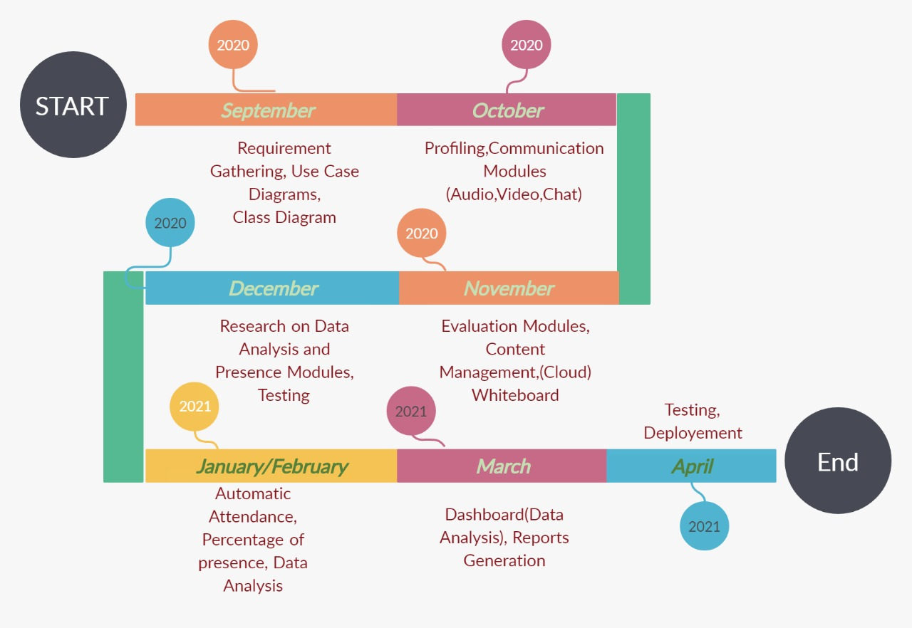**

# **6. Iteration 1**

## **6.1 Expanded use case**

|  |  |  |  |  |  |
| --- | --- | --- | --- | --- | --- |
| **Use Case ID:** | UC-101 | | | | |
| **Use-Case Name:** | Log In To System | | | | |
| **Created By:** | VC Team | | Last Updated By: | | Oct 26, 2020 |
| **Date Created:** | Oct 26, 2020 | | Last Revision Date: | | Oct 26, 2020 |
| **Actors:** | | Student / Teacher / Administrator | | | |
| **Description:** | | Users will be prompted to login with their VC account information before they can use the system. | | | |
| **Preconditions:** | | * The user has an VC account . * The user is trying to log in with their VC account. * The user is not already logged In. | | | |
| **Post conditions:** | | * The user is logged in to the system. * The user has access to the Classroom environment. | | | |
| **Main Success Scenario:** | | Actor   * User accesses the URL. * The system prompts the user for their VC account credentials. * The user enters their VC username and password. * The system authenticates the VC login * The user gains access to the systems functionality | | System   * System allows the User to use its functionalities. | |
| **Alternative Flows:** | | * Invalid VC account user or pass * User already logged in. | | | |
| **Exceptions:** | | * Incorrect credentials. | | | |
| **Frequency of Use:** | | Every time the Student/Teacher/Admin wants to access the system | | | |
| **Assumption** | | The Student/Teacher/Admin wants to use the system. | | | |

|  |  |  |  |  |  |
| --- | --- | --- | --- | --- | --- |
| **Use Case ID:** | UC-102 | | | | |
| **Use-Case Name:** | Log Out of System | | | | |
| **Created By:** | VC Team | | Last Updated By: | | Oct 26, 2020 |
| **Date Created:** | Oct 26, 2020 | | Last Revision Date: | | Oct 26, 2020 |
| **Actors:** | | Student / Teacher / Administrator | | | |
| **Description:** | | The user clicks on Log Out and their session is terminated. | | | |
| **Preconditions:** | | * The user is logged in * The user no longer wants to be logged in. | | | |
| **Post conditions:** | | * The user is logged out | | | |
| **Main Success Scenario:** | | Actor   * User is done using the web application * The user clicks on the logout button * The system logs the user out. | | System   * System logs Out the user. | |
| **Alternative Flows:** | | * N/A | | | |
| **Exceptions:** | | * N/A | | | |
| **Frequency of Use:** | | Whenever the user wants to log out. | | | |
| **Assumption** | | No one can use the login session after a user has successfully logged out. | | | |

|  |  |  |  |  |  |
| --- | --- | --- | --- | --- | --- |
| **Use Case ID:** | UC-103 | | | | |
| **Use-Case Name:** | Register Students | | | | |
| **Created By:** | VC Team | | Last Updated By: | | Dec 14, 2020 |
| **Date Created:** | Dec 14, 2020 | | Last Revision Date: | | Dec 14, 2020 |
| **Actors:** | | Administrator | | | |
| **Description:** | | Student would be able to attend class. | | | |
| **Preconditions:** | | * The user is logged in * The user wants to join the class. | | | |
| **Post conditions:** | | * The Student has joined the class. | | | |
| **Main Success Scenario:** | | Actor   * Admin is using the web application * The Admin clicks on the Register button by entering the Roll # of the students. * The student has joined the class. | | System   * System has allowed students to join the class. | |
| **Alternative Flows:** | | * N/A | | | |
| **Exceptions:** | | * N/A | | | |
| **Frequency of Use:** | | Whenever the Students wants to join the class. | | | |
| **Assumption** | | If the students isn’t registered . He/She can’t join the class | | | |
| **Use Case ID:** | UC-104 | | | | |
| **Use-Case Name:** | Group Chat | | | | |
| **Created By:** | VC Team | | Last Updated By: | | Dec 14, 2020 |
| **Date Created:** | Dec 14, 2020 | | Last Revision Date: | | Dec 14, 2020 |
| **Actors:** | | Students / Teachers | | | |
| **Description:** | | Student / Teacher would be able to message each other in a group during the class. | | | |
| **Preconditions:** | | * The user is logged in * The Student has joined the class. | | | |
| **Post conditions:** | | * The Student is able to send message in a group. | | | |
| **Main Success Scenario:** | | Actor   * Student is using the web application * The user types the message and sends to the group. * The system has delivered the message in a group. | | System   * System has delivered the message in a group Chat. | |
| **Alternative Flows:** | | * N/A | | | |
| **Exceptions:** | | * N/A | | | |
| **Frequency of Use:** | | Whenever the Students wants to Message in the class during the streaming. | | | |
| **Assumption** | | If the students in the session all the | | | |
| **Use Case ID:** | UC-105 | | | | |
| **Use-Case Name:** | Eye Tracking | | | | |
| **Created By:** | VC Team | | Last Updated By: | | Oct 26, 2020 |
| **Date Created:** | Oct 26, 2020 | | Last Revision Date: | | Oct 26, 2020 |
| **Actors:** | | Student | | | |
| **Description:** | | The user’s eye is being tracked by the system | | | |
| **Preconditions:** | | * The user is logged in the system * The user is attending the lecture | | | |
| **Post conditions:** | | * The user is logged in the system | | | |
| **Main Success Scenario:** | | Actor   * Student is using the web application. * The system logs the user out. | | System   * System is tracking Students Eyes. | |
| **Alternative Flows:** | | * N/A | | | |
| **Exceptions:** | | * N/A | | | |
| **Frequency of Use:** | | Every time when the students are taking lectures. | | | |
| **Assumption** | | Students eyes are being tracked by the system. | | | |

## **6.2 Activity Diagram**

## **6.3 Domain Model**

## **6.4. System Sequence Diagram**

#### **C:\Users\ahsaa\Desktop\FYP\Sequence Diagram\LogIn.jpeg6.4.a. UC-101**

### **6.4.a. UC-102**

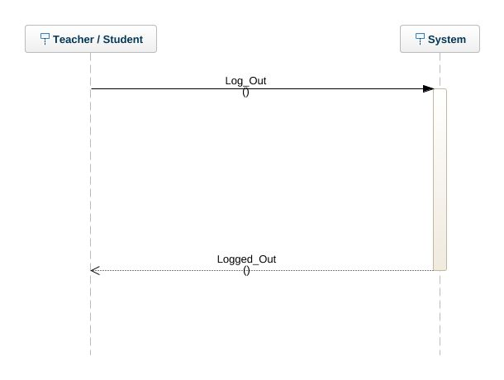

### **6.4.b. UC-103**C:\Users\ahsaa\Desktop\FYP\Sequence Diagram\Manage_Class.jpeg

### **6.4.b. UC-104**

### **6.4.b. UC-105**

### **6.4.b. UC-106**

## **6.5. Operation Contracts**

### **6.5.a. Contract use case ID: UC-101**

**Contract CO1** : Authentication

**Operation Name :** Authentication()

**Cross Reference :** Log In

**Responsibility :** Students/Techer/Admin to login to their sessions.

**Pre-conditions :** Student/Teacher/Admin must be registered in organization and have some unique ID. They should have machine with internet connection to access web application.

### **Post-conditions :**

### Instance of Authentication A created in User\_Class. The Authentication instance is associated with the user class.

### User has been Logged In to the system

### **6.5.b. Contract use case ID: UC-102**

**Contract CO2** : Log Out

**Operation Name :** Log Out()

**Cross Reference :** Log Out

**Responsibility :** Students/Techer/Admin to log Out of their sessions.

**Pre-conditions :** Student/Teacher/Admin must be logged in to the portal with some unique ID. They should have machine with internet connection to access web application.

### **Post-conditions : Instance of Authentication A created in User\_Class. The Authentication instance is associated with the user class.**

User has been Logged Out to the system.

### **6.5.c. Contract use case ID: UC-103**

**Contract CO2** : Manage Class

**Operation Name :** Manage Class

**Cross Reference :** Manage\_Class - Use case

**Responsibility :** Admin to create, remove and assign class.

**Pre-conditions :** Admin must be logged in to the portal with some unique ID.

They should have machine with internet connection to access web application.

**Post-conditions :** Class should have been created. Class is removed if requested. Class is assigned to teacher.

### **6.5.d. Contract use case ID: UC-104**

**Contract CO1** : GroupChat

**Operation Name :** Chat()

**Cross Reference :** Chat

**Responsibility :** Students/Techer would be able to send messages in a group.

**Pre-conditions :** Student/Teacher must be enrolled in a classroom.

### Post-conditions : Instance of Chat is C created in User\_Class. The C instance is associated with the user class.

User has sent message to the classroom chat.

### **6.5.e. Contract use case ID: UC-105**

**Contract CO1** : VideoCalling

**Operation Name :** VideoCall()

**Cross Reference :** VideoCall

**Responsibility :** Students/Techer would be able to Participate in video call.

**Pre-conditions :** Student/Teacher must be enrolled in a classroom.

### Post-conditions : Instance of Call is C created in User\_Class. The C instance is associated with the user class.

User has joined the video call conference.

### **6.5.f. Contract use case ID: UC-106**

**Contract CO1** : EyeTracking

**Operation Name :** EyeTrack()

**Cross Reference :** EyeTrack

**Responsibility :** Students eyes would be tracked during the conference.

**Pre-conditions :** Students must be enrolled in a classroom.

### Post-conditions : Instance of EyeTracking is ET created in User\_Class. The ET instance is associated with the user class.

User’s eye is being tracked..

### **6.5.g. Contract use case ID: UC-107**

**Contract CO1** : ViewDashboard()

**Operation Name :** Dashboard()

**Cross Reference :** Presence Percentage

**Responsibility :** Percentage of presence will be mentioned after the classs at dashboard.

**Pre-conditions :** Faculty will be able to see all the stats of a student.

### **Post-conditions** : Instance corresponding to the User will be created in the user class. Dashboard.display will be called in the user class. The instance is associated with the user class.

# **6.6. Sequence diagrams**

### **C:\Users\ahsaa\Desktop\FYP\Sequence Diagram\Authentication.jpeg6.6.a. UC-102**

### **C:\Users\ahsaa\Desktop\FYP\Sequence Diagram\Manage Class_SD.jpeg6.6.a. UC-103**

### **C:\Users\ahsaa\Downloads\WhatsApp Image 2020-12-18 at 4.30.35 PM.jpeg6.6.1 a. UC-103**

## **6.7. Class Diagram**

## **6.8 Entity Relationship Diagram**

## **6.9. Architecture diagram**

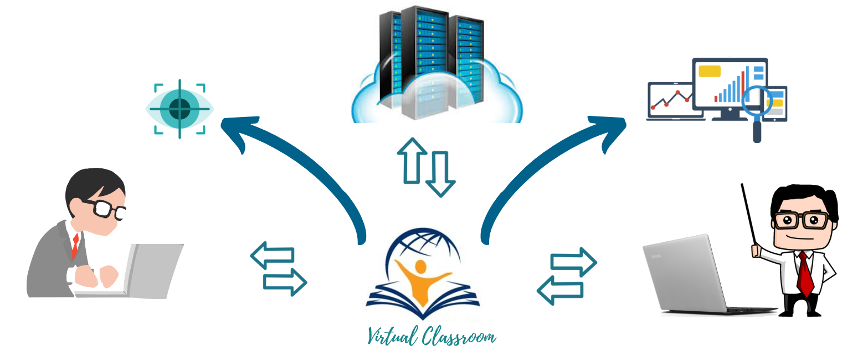

# **7 Deployment diagram**



# **8 Implementation Details**

## **Front-End Implementation :**

**Bootstrap:** - Bootstrap is a free and open-source CSS framework directed at responsive, mobile-first front-end web development. It contains CSS- and JavaScript-based design templates for typography, forms, buttons, navigation, and other interface components. We have used bootstrap for designing our platform.

## **Back-End Implementation :**

## **API’s and Libraries:**

**Django :**

For the complete development environment, we have used the Django framework of Python. We used Django because most of our modules like communication modules, eye tracking, and then facial recognition, were implemented in python, so the best framework out of our choices was Django. We could also use flask but we wanted to have a Monolithic working style and also it's easy and simple to implement.

**MySQL (Database) :**

For the database, we have used MySQL which is connected to Django using Django ORM. ORM is the most powerful feature of Django which provides a pythonical way to create SQL to query and manipulate databases and get results in a pythonic fashion.

**TWILIO: -**

For the communication modules, we have used Twilio API which has democratized communications channels like voice, text, chat, video, and email by virtualizing the world’s communications infrastructure through APIs that are simple enough for any developer to use, yet robust enough to power the world’s most demanding applications.

Twilio features that we have used are:-

* Video Call
* Chat
* Screen Recording
* Screen Sharing

## **Open CV - Eye Tracking :**

We have used Eye tracking to measure the percentage of presence during the class. First, we recognize the student's face to ensure that the student sitting in front of the class/camera is exactly the one whose account is logged in. Then our tool detects the eyes of that face using OpenCV and Dlib to check the focus of the eye whether their eyes are focused on the lecture/presentation. We are getting the students' coordinates, and based on some analytics, the tool measures the percentage of presence. That figure of the percentage of presence will be displayed in the dashboard of that specific student. By visualizing the dashboard, the Teacher would understand the interest of that student in presence. Those recommendations will be sent to the students and teachers both, and also, based on its result, the student will be marked present or absent.

**Tkinter :**

Tkinter is a library provided by python to implement GUI applications. We used this to draw a whiteboard during the lecture. We used a canvas, and in that canvas, we used mouse events. Whenever the mouse button is pressed, we draw a line when the mouse is pressed. Our implementation is only working on a laptop. Still, we'll try to integrate it into our virtual environment tool so that it can provide full ease to the Institutional mentors and then the students.

**Facial Recognition :**

In order to do facial recognition of the student during the lecture, we used the facial recognition library of python. We measured the 128 values of the face of the student during the registration princess when the student uploads the profile picture of him/her. Now we store those 128 values in the database and during the lecture, we get the frames from the live camera of student and we calculate the face values of student at runtime and compare those with the 128 values we stored in the database and that’s how we do the facial recognition.

# **9 User Manual**

## **Registration Of Student**

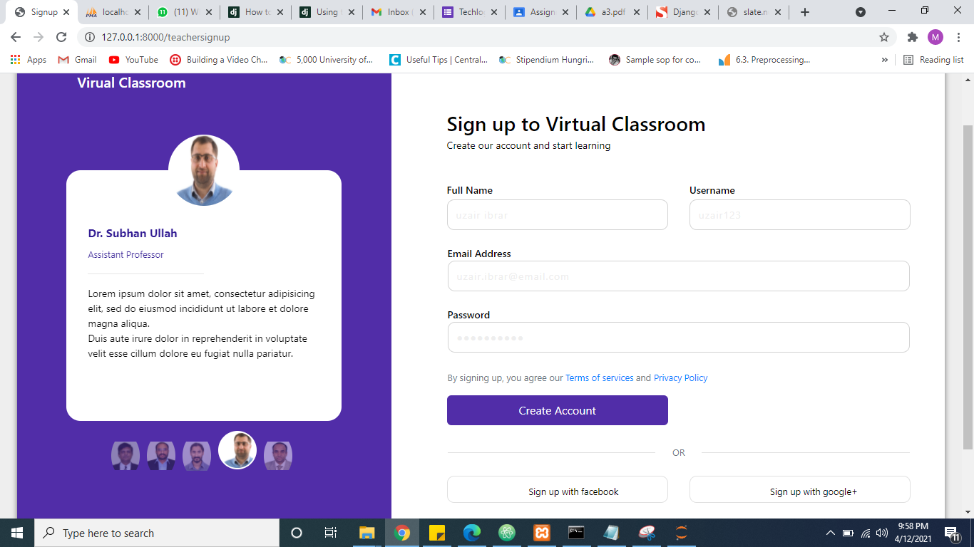

Admin Of the Educational Institute will create a profile of the student on the portal, to allow him the access to all the features of the platform , through which he/she can attend classes and can have access to all the resources of the course. Also where the system will maintain his attendance through facial recognititon.

## **Log In to the System**

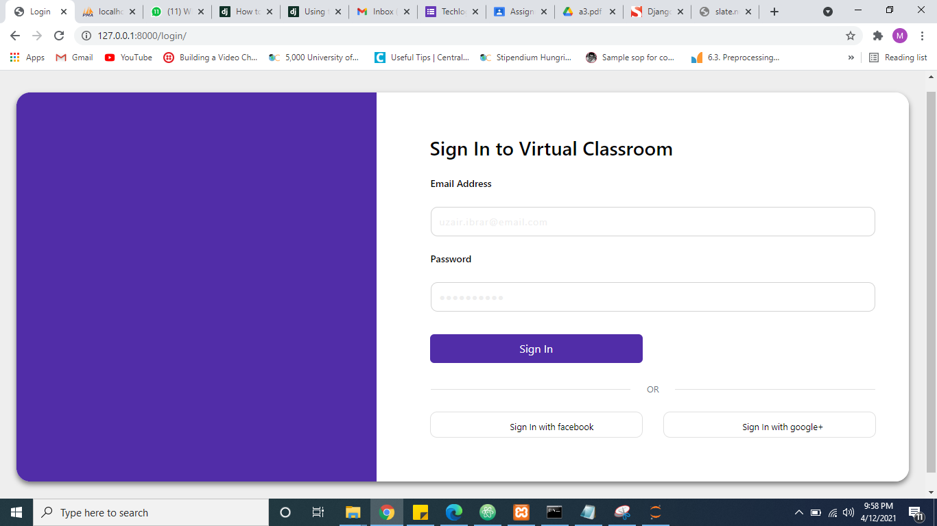

Here is the Log In Of the System , through which student can Log In to the system to access all the classes and the content of the course , his/her attendance will be recorded by the system using facial recognition. After log in the system will allow him to interact with his faculty.

## **Access to the System**

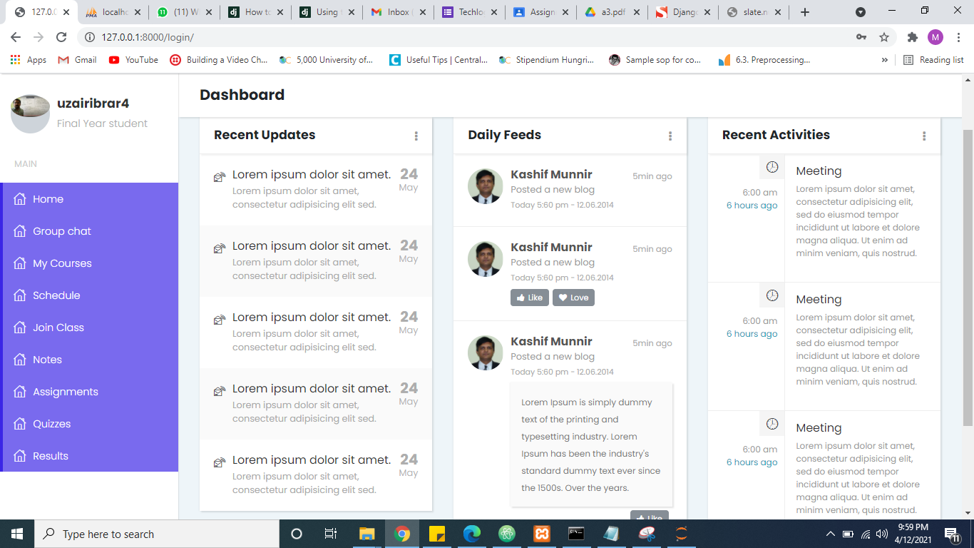

After logging in to the system , Student will be able to receive notification for announcement. Student can see the notes. Quizzes , schedule and can join the class as well.

## **Video Conferencing**

After logging in to the system, Student will be able to join the live session / video conferencing in class. That enables students to get in touch with their professors. It provides mentors and ease of marking attendance automatically and measures the percentage of presence at the end of the class for each student in the class.

## **Whiteboard**

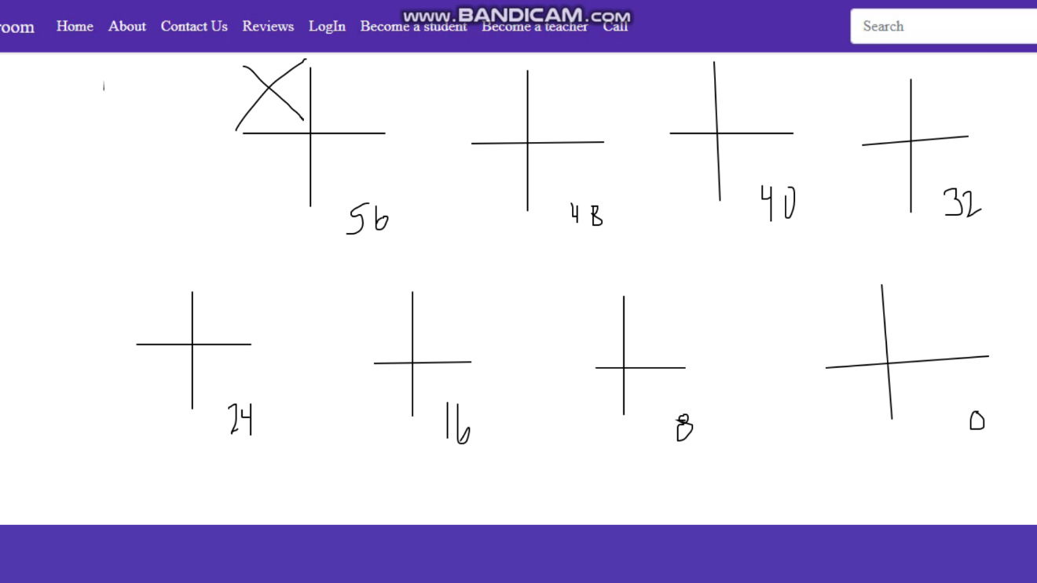

White board makes it easy for the teachers and students to clear the concept of the topic more clear in virtual classes, By using whiteboard it is very easy for the students to get the idea about the course topic. It helps in better understanding.

## **Time Schedule**

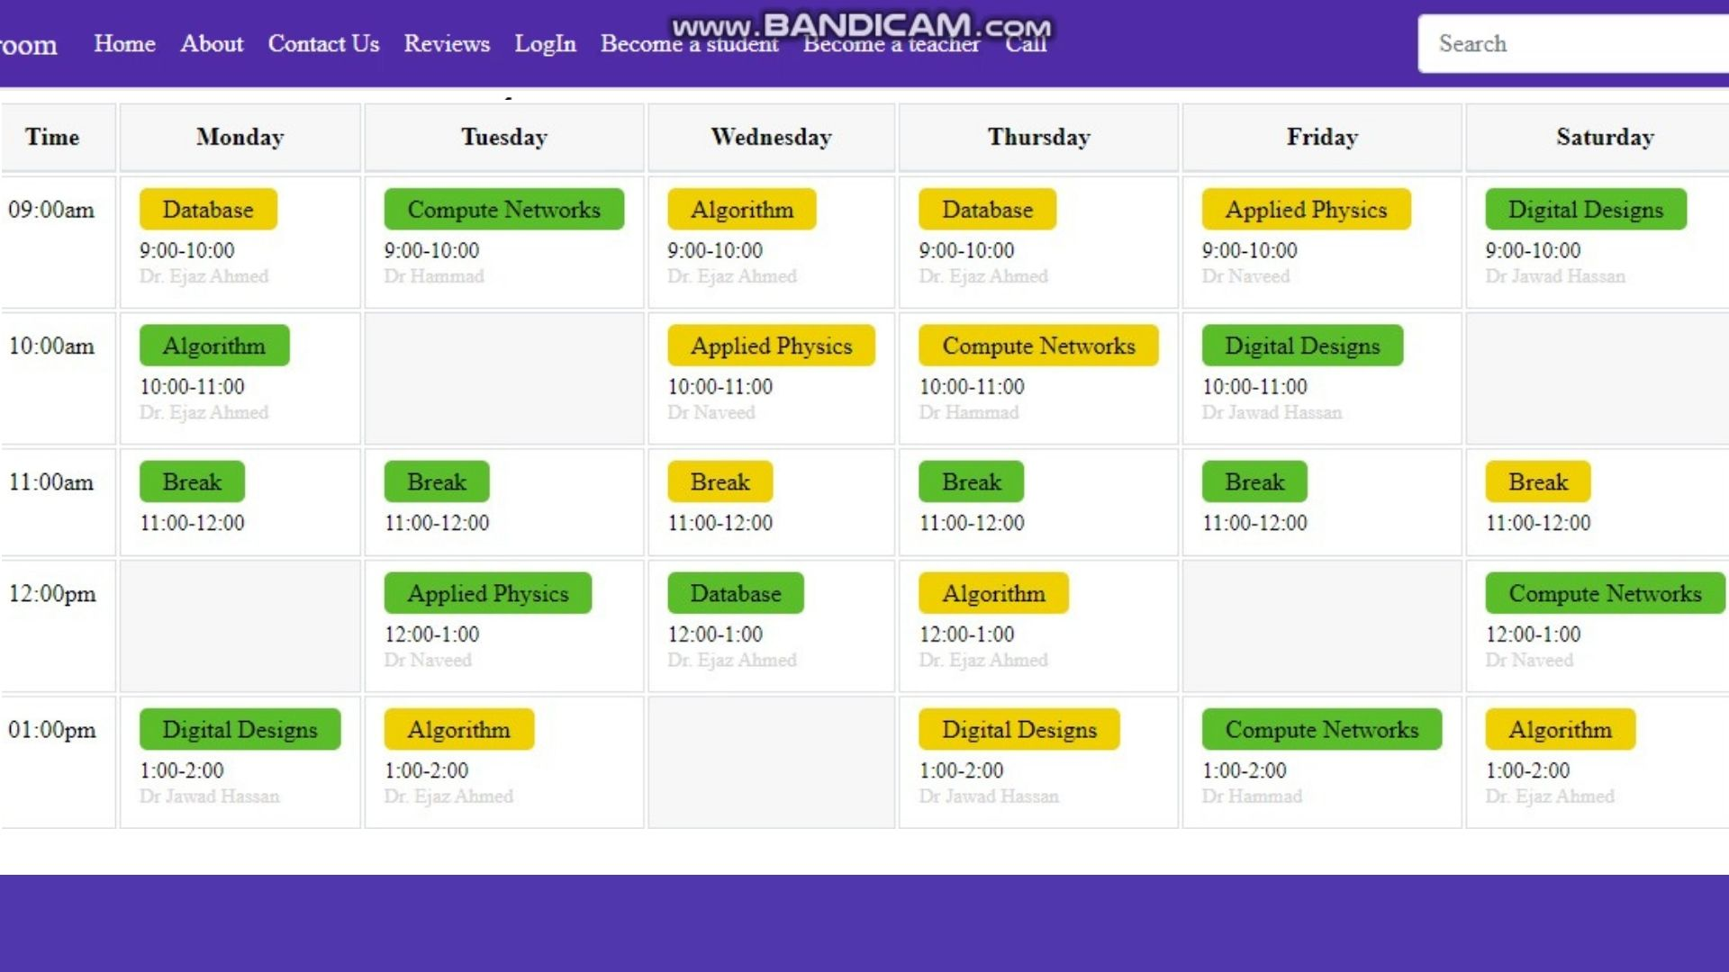

Schedule provides the time table for classes, it also provides the information about the teacher who will be taking the class and the time on which the class will be conducted. It makes it very for the faculty and the students to know about the schedule of their classes.

## **Screesharing**

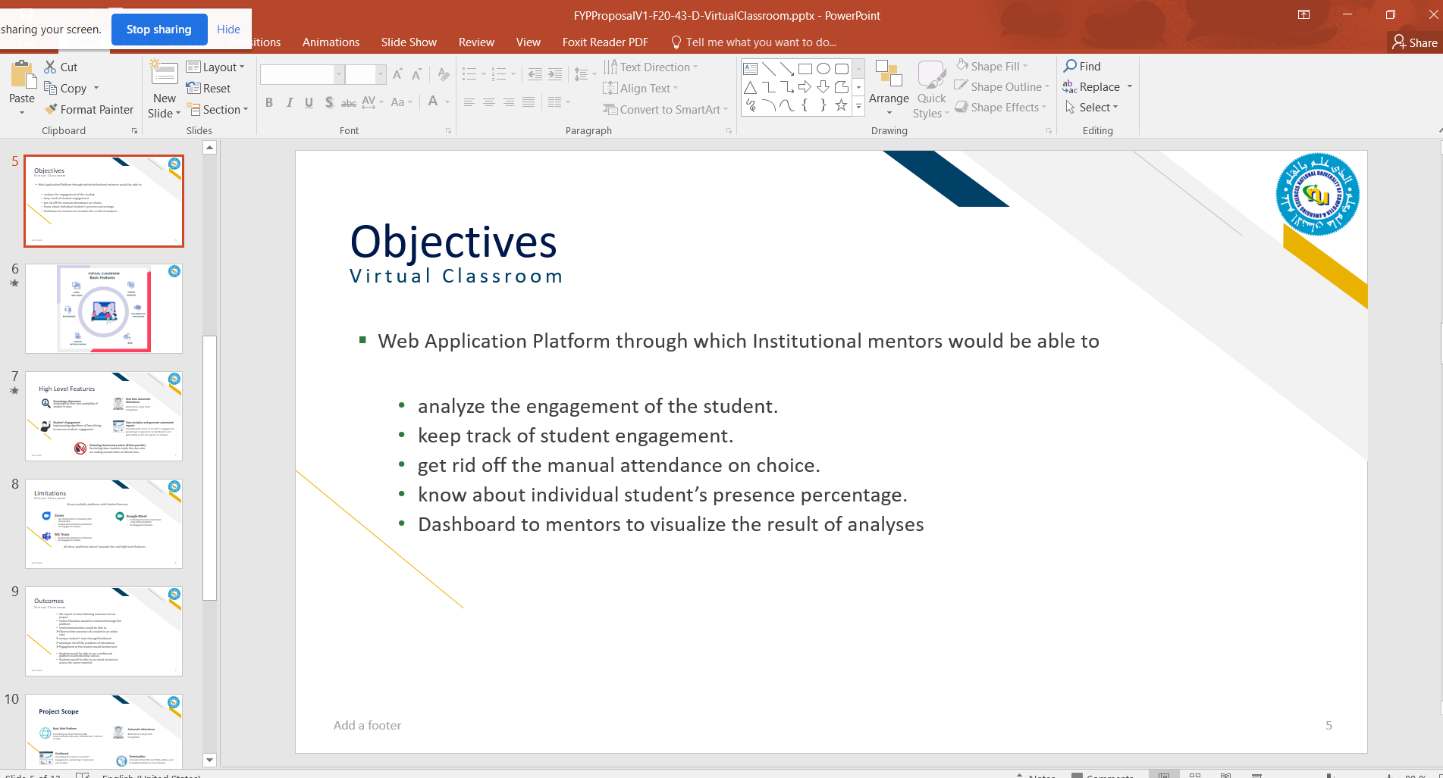

Tool provides an ease to share your screen to the audience as well, you can see the content of your teacher’s screen easily in order to get better understanding of the topic/lecture. You can also share your screen to the audience to display anything that you want to share with them..

# **Problems Faced:**

During the Virtual Classroom implementation, the main problem we faced was integrating APIs in our web project. As this project was done using the Twilio API for the communication between the different types of users, i.e., Institutional mentors and Students, it doesn't allow access to the frames. Still, we needed frames for applying digital Image processing on it so that we can check the student's engagement in the class, like whether it's looking on the laptops' screen or not?

Another problem we faced was the Implementation of the admin side. According to our perspective, the course registrations and assigning courses to the institutional mentors should be done by the administration. Hence we needed separate implementation of the admin side of our project, but we didn't have enough time left as the deadline was approaching.

# **Conclusion**

I learned that virtual classrooms have some benefits, such as; reducing the cost of studying abroad and helping the environment from the carbon footprint. However, there are also some problems like; the technical challenges and the lack of relationship between the teacher and the students. From my point of view, a virtual classroom is more comfortable than a normal classroom. The virtual classroom transcends location, time, and space, providing a flexible learning environment for all. Schools, universities and corporate organizations benefit form Virtual classrooms because it provides an excellent way for experts to teach a geographically dispersed group of students without hassle.